ORDER FORM

You may find it convenient to use this order form, but we are pleased to receive orders in any form that you may choose.
Please give details of the embroidery you require.
It would be helpful if existing customers quoted their account number.

PAYMENT TERMS: No deposit is required. We expect payment 14 days after you receive your order.

Order to be sent to: Club, Company or Group name Click here to enter text.

Your own name Click here to enter text.
Address Click here to enter text.
Postcode Click here to enter text. Email Address Click here to enter text.
Phone Number Click here to enter text.. Mobile Number Click here to enter text.
Account Number Click here to enter text.

Signature _____________________________________ Date Click here to enter a date.

By returning this document electronically, you are agreeing to our terms and conditions, and authorising the order detailed below without the need for a signature.

GARMENT | CODE NO. | QUANTITY | SIZE | COLOUR | EMBROIDERY ☐  HEAT PRESS ☐ | ADDITIONAL NAMES & POSITION OF LOGO  Please specify exactly what you would like and in which position
 |  |  |  |  | Choice of Logo (Code Number if known)  Position of Logo (Please mark on diagram below) | BLOCK CAPITALS ☐  Script (available for ☐ embroidery only)
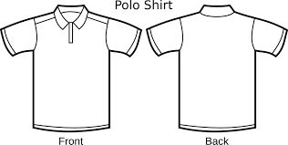Please continue on a separate sheet if necessary

Click the control box of the location of your logo (you cannot click on the image)

☐ ☐ ☐

☐  ☐ | 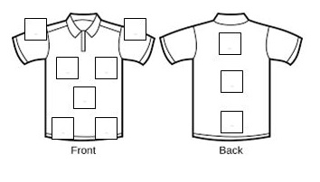 | ☐
 | ☐ ☐ ☐ ☐

Additional Notes:

